🤖 AI Quiz Generator - Project Documentation
1. Project Overview
AI Quiz Generator is a full-stack application that generates multiple-choice quizzes using Mistral AI, automates the backend using n8n, stores data in Supabase PostgreSQL, and displays the quiz through a React frontend.
The user selects:
- Topic
- Difficulty
- Number of questions
The system generates the questions, stores them, retrieves them using a quiz_id, and allows the user to attend and review the quiz.

2. Technologies Used
Technology | Purpose
React.js | Frontend
Axios | API requests
React Router | Page navigation
n8n | Backend workflow/API
Mistral AI | Question generation
Supabase | Database
PostgreSQL | Data storage

3. How the Project Works
User
↓
React Frontend
↓
n8n Webhook
↓
Mistral AI
↓
n8n Processing
↓
Supabase
↓
n8n Response
↓
React
There are two n8n workflows:
Workflow 1 - Generate Quiz
Creates a new quiz and stores all questions.
Workflow 2 - Get Quiz
Retrieves an existing quiz and its questions using quiz_id.

4. Database Setup
Create a Supabase project and create these two tables.
Quizzes
Column Name | Data Type | Constraint / Description
id | bigint | Primary Key, Auto-generated
topic | text | Quiz topic
difficulty | text | Quiz difficulty level
number_of_questions | integer | Number of questions in the quiz
created_at | timestamp | Date and time when the quiz was created

Example
id | topic | difficulty | number_of_questions | created_at
511 | Java | Easy | 15 | 2026-08-17 09:56:29

Questions

Column Name | Data Type | Constraint / Description
id | bigint | Primary Key, Auto-generated
quiz_id | bigint | Foreign Key → quizzes.id
question | text | Quiz question
option_a | text | First answer option
option_b | text | Second answer option
option_c | text | Third answer option
option_d | text | Fourth answer option
correct_answer | text | Correct answer
explanation | text | Explanation for the correct answer
created_at | timestamp | Date and time when the question was created

Relationship
quizzes.id
↓
questions.quiz_id
One quiz can therefore have many questions.

5. Workflow 1 - Generate Quiz
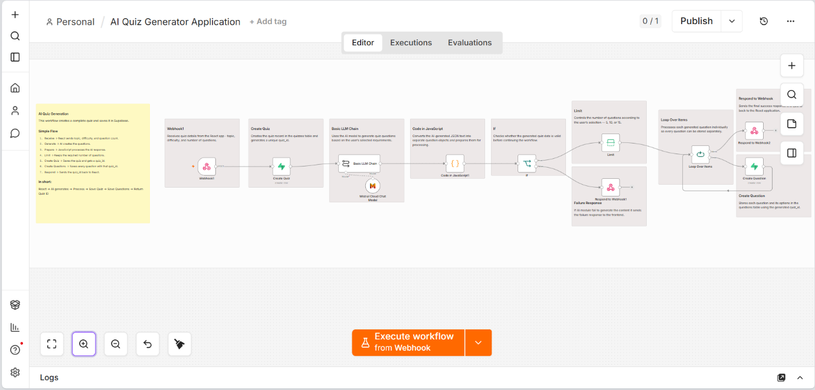
Purpose
Creates a quiz from the user's input and saves the generated questions in Supabase.
Flow
React
↓
Webhook
↓
Create Quiz
↓
Mistral AI
↓
JavaScript
↓
IF
↓
Limit
↓
Loop Over Items
↓
Create Question
↓
Respond to Webhook
What Each Step Does
1. Webhook
Receives topic, difficulty, and number_of_questions from React.
2. Create Quiz
Creates a record in quizzes and generates the quiz_id.
3. Mistral AI
Generates the requested multiple-choice questions.
4. JavaScript
Converts the AI response into usable JSON items.
5. IF
Checks whether the generated data is valid.
6. Limit
Ensures only the requested number of questions continues.
7. Loop Over Items
Processes questions one by one.
8. Create Question
Stores each question in Supabase using the same quiz_id.
9. Respond to Webhook
Returns the generated quiz_id to React.
Example response:
{
"success": true,
"message": "Quiz generated successfully",
"quiz_id": 511
}

6. Workflow 2 Get Quiz
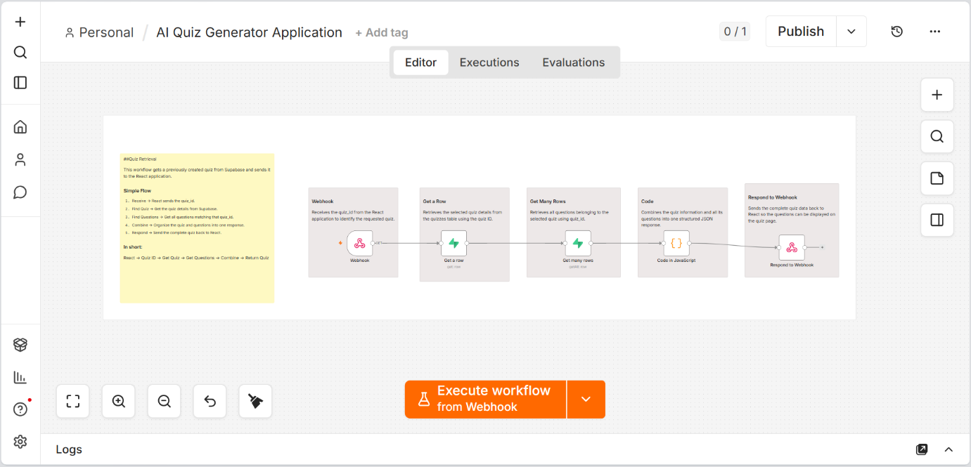
Purpose
Retrieves the quiz and its questions using the quiz_id.
Flow
React
↓
Webhook
↓
Get a Row
↓
Get Many Rows
↓
JavaScript
↓
Respond to Webhook
What Each Step Does
1. Webhook
Receives the quiz_id from React.
2. Get a Row
Gets the quiz details from the quizzes table.
3. Get Many Rows
Gets all questions where:
questions.quiz_id = quiz_id
4. JavaScript
Combines quiz information and questions into one JSON response.
5. Respond to Webhook
Sends the complete quiz data back to React.

7. Frontend Flow
The React application follows this flow:
Login
↓
Home
↓
Select Topic + Difficulty + Question Count
↓
Generate Quiz
↓
Receive quiz_id
↓
Get Quiz
↓
Quiz Page
↓
Submit Answers
↓
Calculate Score
↓
Result
↓
Review Answers
React communicates with n8n using Axios POST requests.

8. Important Data Flow - quiz_id
The quiz_id is the most important value in the project.
Create Quiz
↓
quiz_id = 511
↓
Question 1 → quiz_id = 511
Question 2 → quiz_id = 511
Question 3 → quiz_id = 511
↓
Stored in Supabase
↓
React requests quiz_id = 511
↓
Get Quiz Workflow
↓
Returns Quiz + Questions
If questions are missing, the first thing to check is whether the correct quiz_id is being passed.

9. Recreate the Project
Follow these steps to recreate the project from the GitHub repository.
Step 1 - Clone Repository
git clone https://github.com/Jeswin-Madona/AI-Quiz-Generator.git
Step 2 - Setup Supabase
- Create a Supabase project.
- Create the quizzes table.
- Create the questions table.
- Configure the required columns and relationship.
Step 3 - Setup n8n
- Open n8n.
- Import the workflow files from /workflows.
- Configure Supabase credentials.
- Configure Mistral AI credentials.
- Activate the workflows.
- Copy the webhook URLs.
Step 4 - Setup React
cd frontend/Quiz\ React
npm install
npm run dev
Update the frontend API URLs with the n8n webhook URLs.
Step 5 - Test
- Open the React application.
- Select topic, difficulty, and question count.
- Generate a quiz.
- Verify the quiz and questions in Supabase.
- Verify that React receives the quiz_id.
- Open the quiz and verify all questions are displayed.
- Complete the quiz and check the result/review pages.

10. Troubleshooting
Quiz not generated
Check:
React Request
↓
Webhook
↓
Mistral Response
↓
JavaScript JSON
Wrong number of questions
Check the Limit node.
Questions not stored
Check:
Loop Over Items
↓
Create Question
↓
quiz_id
Quiz not retrieved
Check:
React quiz_id
↓
Get a Row
↓
Get Many Rows
↓
questions.quiz_id
undefined quiz ID
Make sure Create Quiz executes before Create Question and that its generated ID is correctly passed to the question insertion node.

11. Security
Never commit these values to GitHub:
- Mistral API keys
- Supabase credentials
- Database passwords
- Private webhook URLs
Use n8n Credentials and environment variables for sensitive information.

12. Project Structure
AI-Quiz-Generator/
│
├── frontend/
│ └── Quiz React/
│
├── workflows/
│ ├── Generate Quiz.json
│ ├── Get Quiz.json
│ └── README.md
│
├── screenshots/
│
└── README.md

13. Final Understanding
The entire project can be remembered with two flows:
Generate
React → n8n → Mistral AI → Supabase → quiz_id → React
Retrieve
React → quiz_id → n8n → Supabase → Quiz + Questions → React
The React frontend handles the user interface, n8n handles the application workflow, Mistral AI generates the questions, and Supabase stores the data.
This separation makes the project easier to understand, debug, and extend.

